Chart Start
1. To begin, open the Chart Start.rdl report to the Design tab and double-click
the Chart tool in the Toolbox to bring up the Select Chart Type dialog box. The
Chart objects in SSRS 2008 were enhanced quite extensively, but mostly the
updates are cosmetic. You will select the Stacked Bar chart shown in
Figure 5-1.

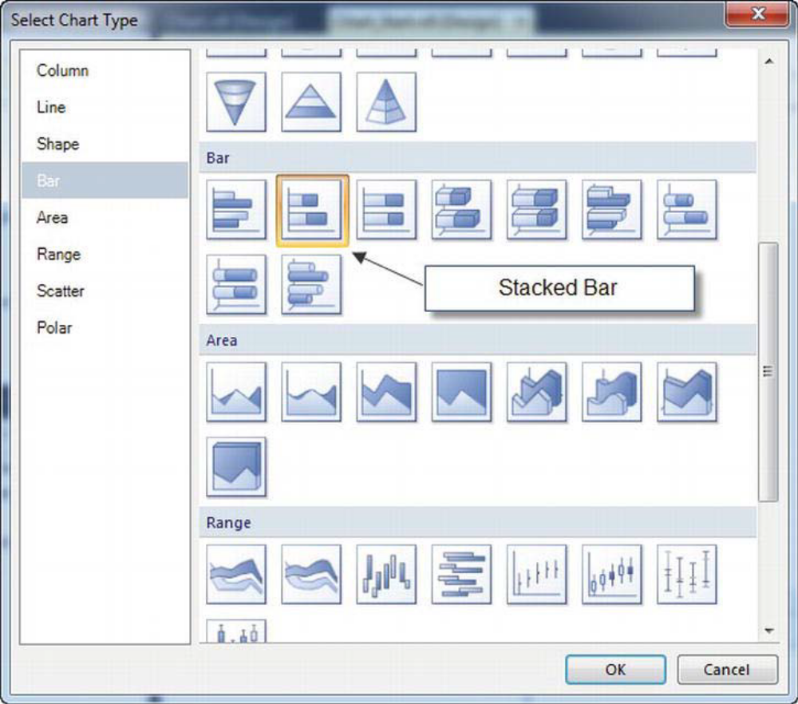

Figure 5-1. SSRS chart selections

2. Double click the graphic area of the chart, which will bring up the Chart Data
window.
3. Under the Values area of the Chart Data window click the green plus sign and
select Visit_Count from the drop down list.
4. Next, click the green plus sign in the Category Groups area of the Chart Data
window and select Employee_Name.
5. Next, click the green plus button in the Series Group area of the Chart Data
window and select Patient_Name
6. Finally, resize the chart by dragging the bottom right corner down and to the
right so it resembles Figure 5-2.

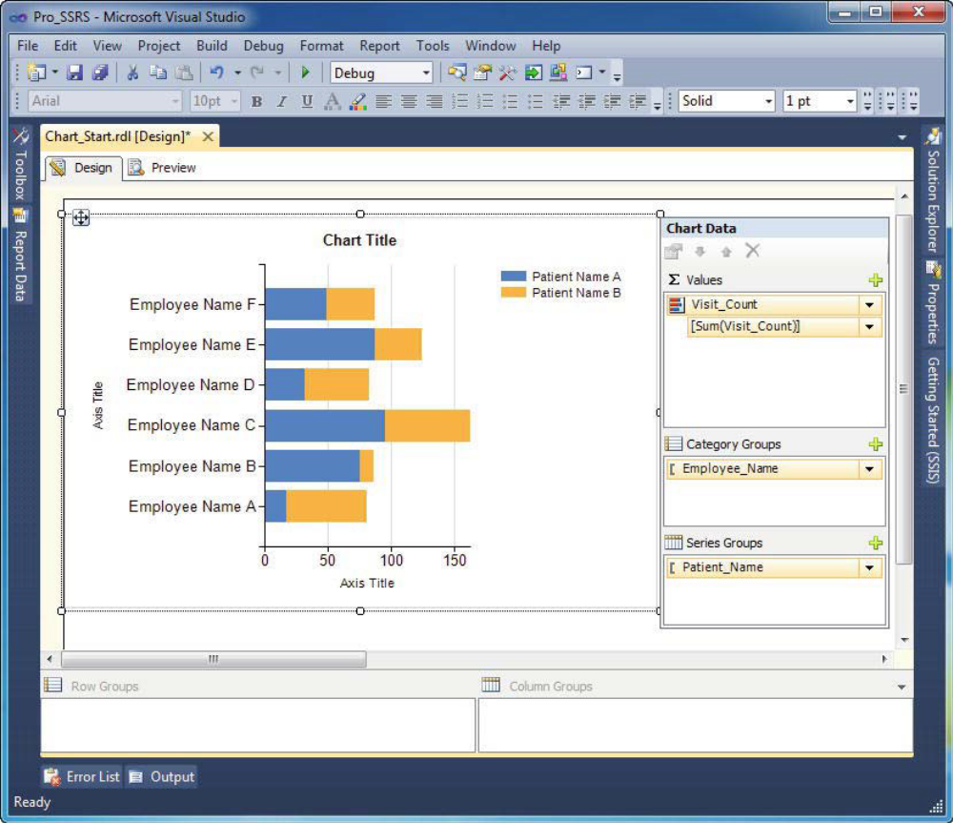

Figure 5-2. Chart with three fields
Before you preview the chart, let’s look at its properties. You will want to change the default palette
to Light for a more subtle and visually appealing view. Right click in the chart and select Chart Properties
under the Chart submenu. Choose the color palette named Light and select OK. The properties should
look like Figure 5-3.

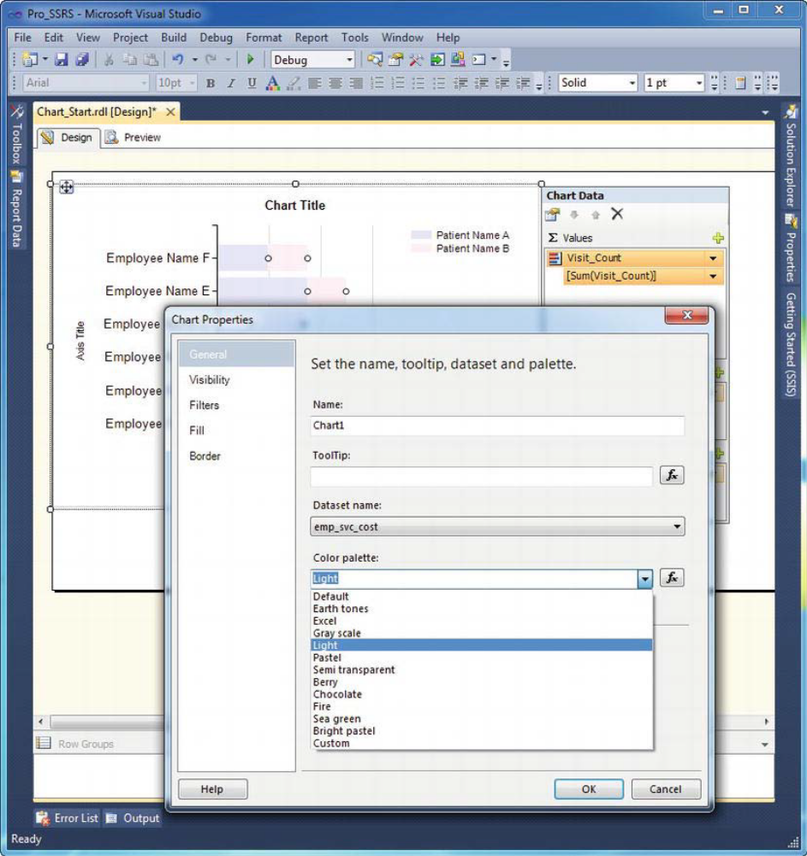

Figure 5-3. Chart properties

Finally, right-click inside of the chart graphic area while on the Design tab, and select 3D Effects.
Next, click the checkbox to enable 3D effects and click OK. Before previewing the chart, rename the title
from Chart Title to Visit Count By Patient. You can now preview the chart, as displayed in Figure 5-4.

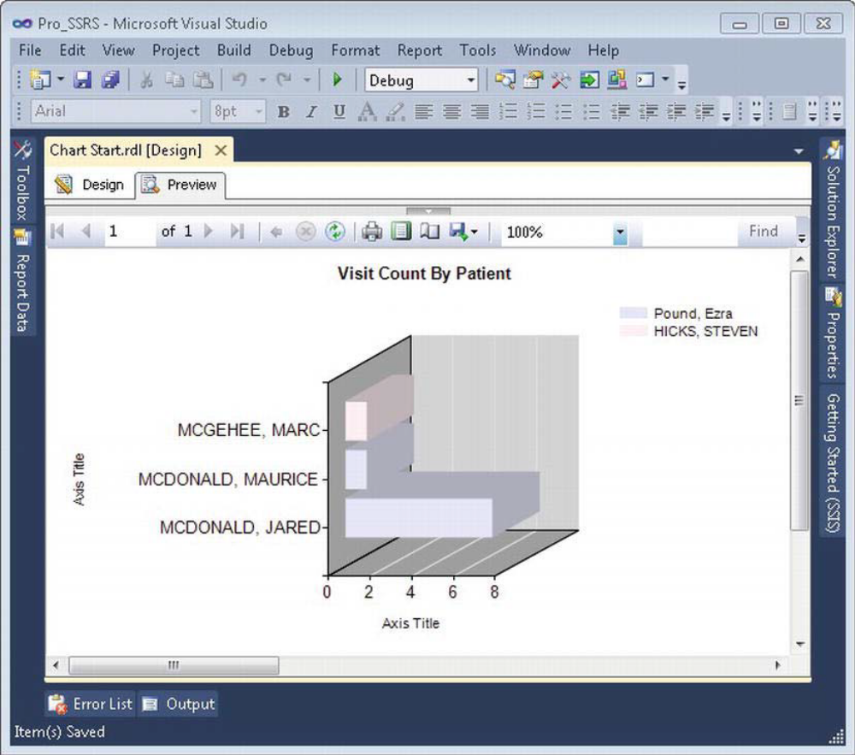

Figure 5-4. Chart with custom properties

